Biraban Public School P&C
Uniform Shop
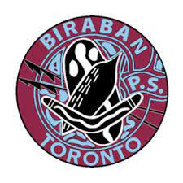
P&C Uniform shop prices will increase as of the start of Term 3; this increase is due to prices increasing from our suppliers.
Uniform shop will be open fortnightly on Wednesday’s from 8.30am till 10.30am & 2pm till 3pm.
Orders can be emailed to birabanunifom@outlook.com , orders can be sent through anytime once orders are received they will be filled and sent home with your child ASAP depending on stock availability.
Order forms are also available in front office to be filled out and can be given back to Amanda (uniform shop coordinator) or P&C Letterbox located outside canteen.
Payment methods – Bank transfer / Card (square) in person .NO CASH ACCPETED
Name – Biraban School P&C Uniform
BSB – 650 000 Account Number – 552517008
Reference – Child’s Name
Email address – birabanuniform@outlook.com
Opening days for the remaining of the year -
Wednesday 19th July 2023 – 8.30am till 10.30am & 2pm till 3pm
Wednesday 2nd August 2023 – 8.30am till 10.30am & 2pm till 3pm
Wednesday 16th August 2023 – 8.30am till 10.30am & 2pm till 3pm
Wednesday 30th August 2023 – 8.30am till 10.30am & 2pm till 3pm
Wednesday 13th September 2023 – 8.30am till 10.30am & 2pm till 3pm
Wednesday 11th October 2023 – 8.30am till 10.30am & 2pm till 3pm
Wednesday 25th October 2023 – 8.30am till 10.30am & 2pm till 3pm
Wednesday 8th November 2023 – 8.30am till 10.30am & 2pm till 3pm
Wednesday 22nd November 2023 – 8.30am till 10.30am & 2pm till 3pm
Wednesday 6th December 2023 – 8.30am till 10.30am & 2pm till 3pm

