Biraban Public School P&C
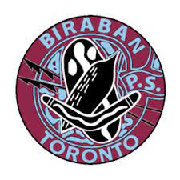
Uniform Shop Price List
As of July 2023

Gaberdine Skort | $20.00
A Line Skirt | $16.00
Dress Polo Shirt | $27.00
Boys Grey Cargo Shorts | $20.00
Sport Polo Shirts | $17.00
Maroon Shorts | $16.00
Cap | $11.00
Bucket Hat | $11.00
Wide Brim Hat | $13.00
Track Pants | $21.00
Fleecy Jacket | $27.00
Wet Weather Jacket | $40.00
Jumper | $17.00

Please note prices have increased due to costs from suppliers going up.

